|  |  |  |  |
| --- | --- | --- | --- |
| PHASE3 | | | |
| Project name | EE 477 Final Project | | |
| Document ref |  | | |
| Version | 1.0 | | |
| Release date | 20220503 | | |
| Author | Fei Wu, Haoda Wang, Jason Yik | | |
| Classification |  | | |
| Distribution List | Fei Wu PHASE3 | | |
| Approved by | Name | Signature | Date |
|  |  |  |  |



**Ming Hsieh Department of Electrical Engineering**

**University of Southern California, Los Angeles, CA 90089**

**Spring 2022**

**EE 477**

Revision History

|  |  |  |  |
| --- | --- | --- | --- |
| **Date** | **Version** | **List of changes** | **Author + Signature** |
|  |  |  |  |
|  |  |  |  |
|  |  |  |  |
|  |  |  |  |
|  |  |  |  |
|  |  |  |  |
|  |  |  |  |
|  |  |  |  |
|  |  |  |  |
|  |  |  |  |
|  |  |  |  |
|  |  |  |  |
|  |  |  |  |
|  |  |  |  |
|  |  |  |  |
|  |  |  |  |
|  |  |  |  |
|  |  |  |  |
|  |  |  |  |

C A T A L O G

1 General Guidelines 5

2 MUL 6

2.1 AND2X4 6

2.1.1 Layout 6

2.1.2 LVS 6

2.1.3 DRC 7

2.2 ADDER1bit 7

2.2.1 Layout 7

2.2.2 DRC 8

2.2.3 LVS 8

2.3 MUL 8

2.3.1 Changes 8

2.3.2 Layout 10

2.3.3 DRC 13

2.3.4 LVS 13

3 Divider 14

3.1 Halfsub 14

3.2 Fullsub 15

3.2.1 Loyout 15

3.2.2 LVS 16

3.2.3 DRC 17

3.3 FullSubmux 18

3.3.1 Layout 18

3.3.2 DRC 19

3.3.3 LVS 20

3.4 HalfsubMux 21

3.4.1 Layout 21

3.4.2 LVS 21

3.4.3 DRC 22

3.5 Divider 22

3.5.1 Layout 22

3.5.2 LVS 25

3.5.3 DRC 25

4 FSM 26

4.1 DFF 26

4.1.1 Layout 26

4.1.2 DRC 27

4.1.3 LVS 27

4.2 Arbiter 28

4.2.1 Layout 28

4.2.2 LVS 29

4.2.3 DRC 29

4.3 FSM 30

4.3.1 Layout 30

4.3.2 DRC 32

4.3.3 LVS 32

4.4 Report **Error! Bookmark not defined.**

# General Guidelines

[General Guidelines](https://blackboard.usc.edu/webapps/blackboard/content/listContent.jsp?course_id=_294497_1&content_id=_8570610_1)

You are allowed to use the logic cells and circuits you designed in previous labs, or redesign them.

Use Vdd = 1.8V

Use rise and fall time for all input stimuli = 10ps (Note that it is NOT 100)

Every primary input and primary output of the design should be connected a flip-flop.

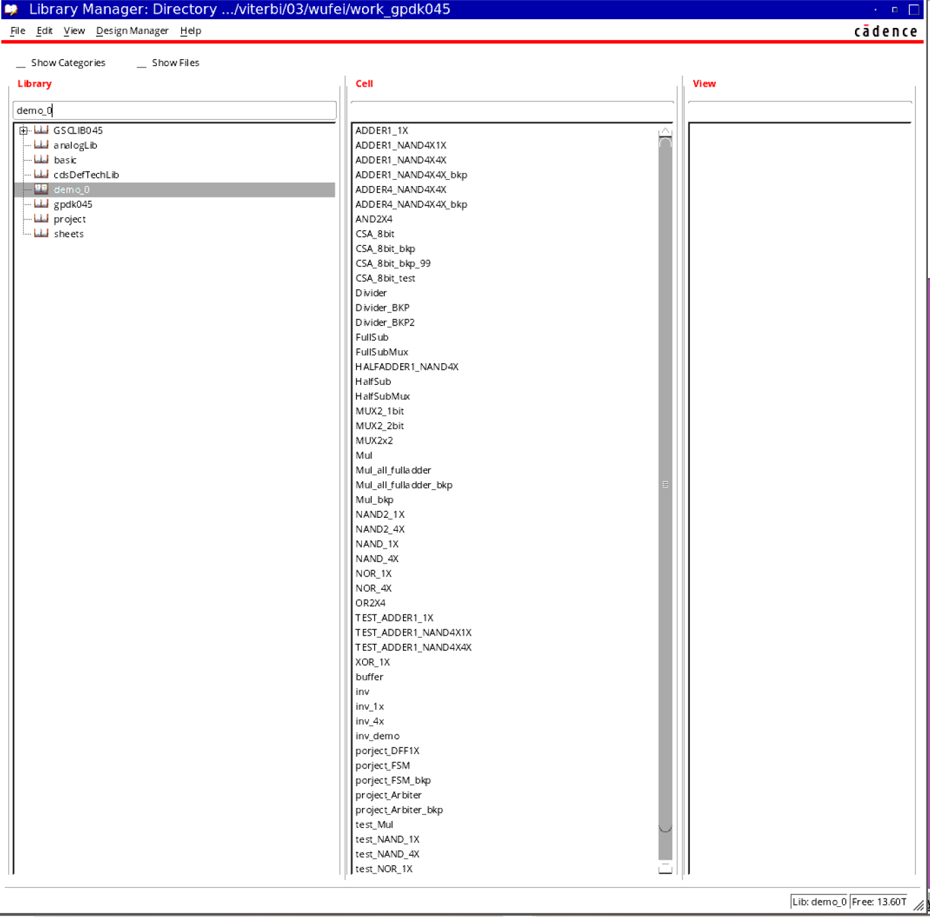

# MUL

## AND2X4

### Layout

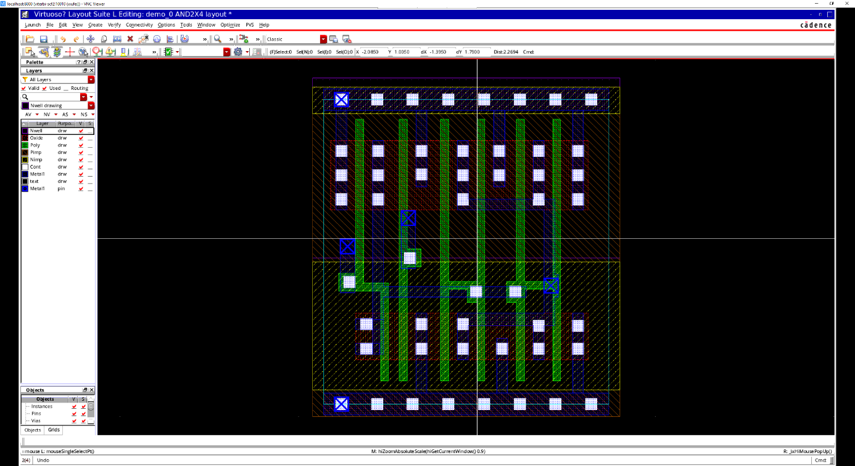

### LVS

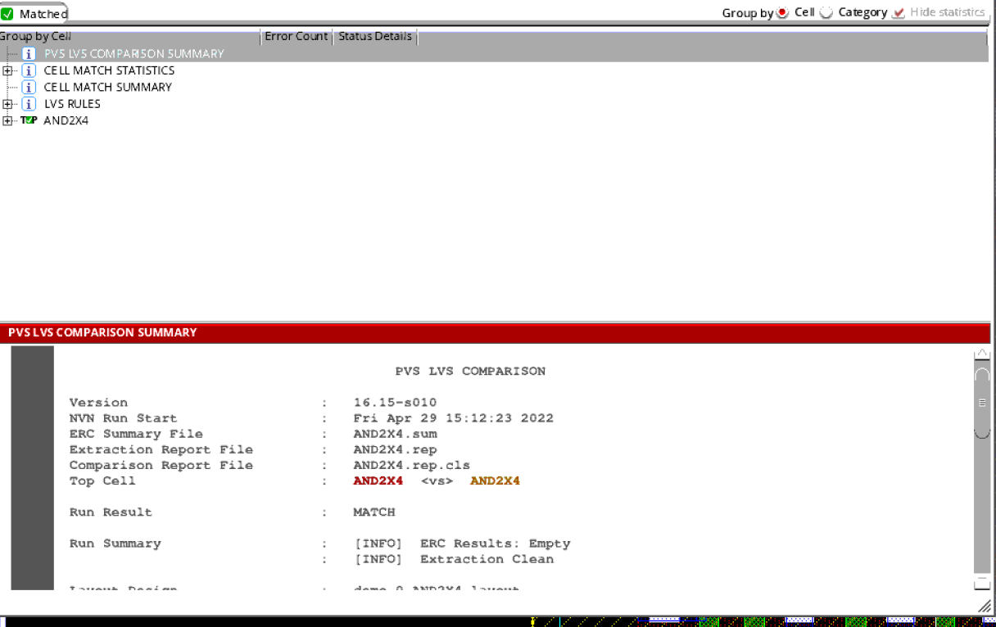

### DRC

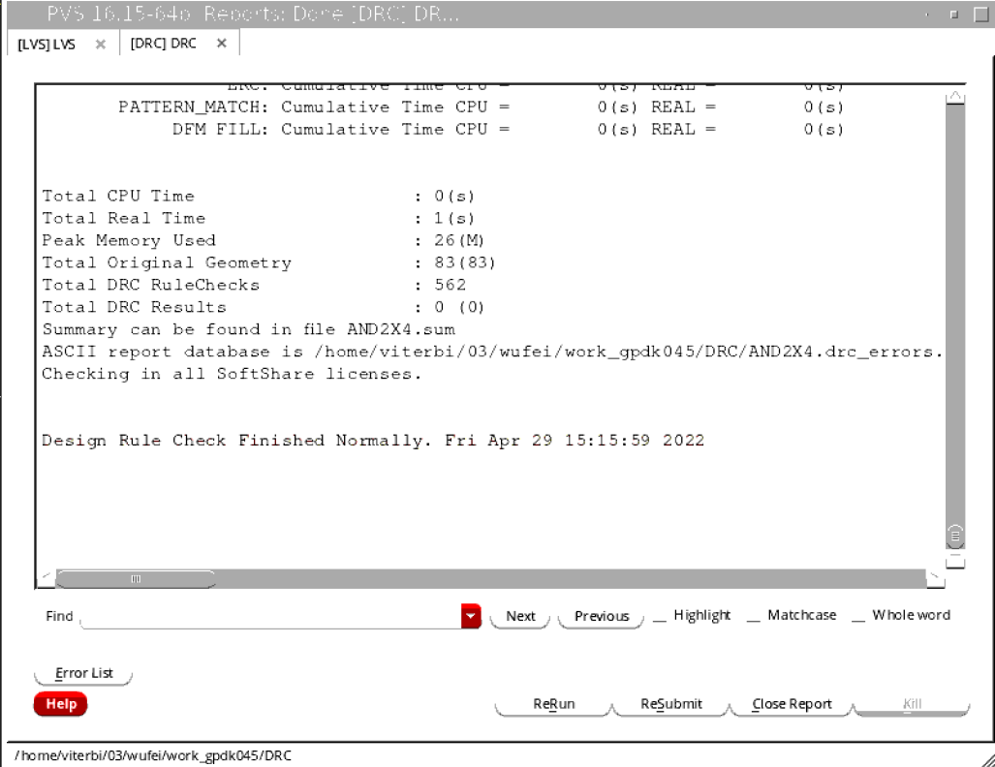

## ADDER1bit

### Layout

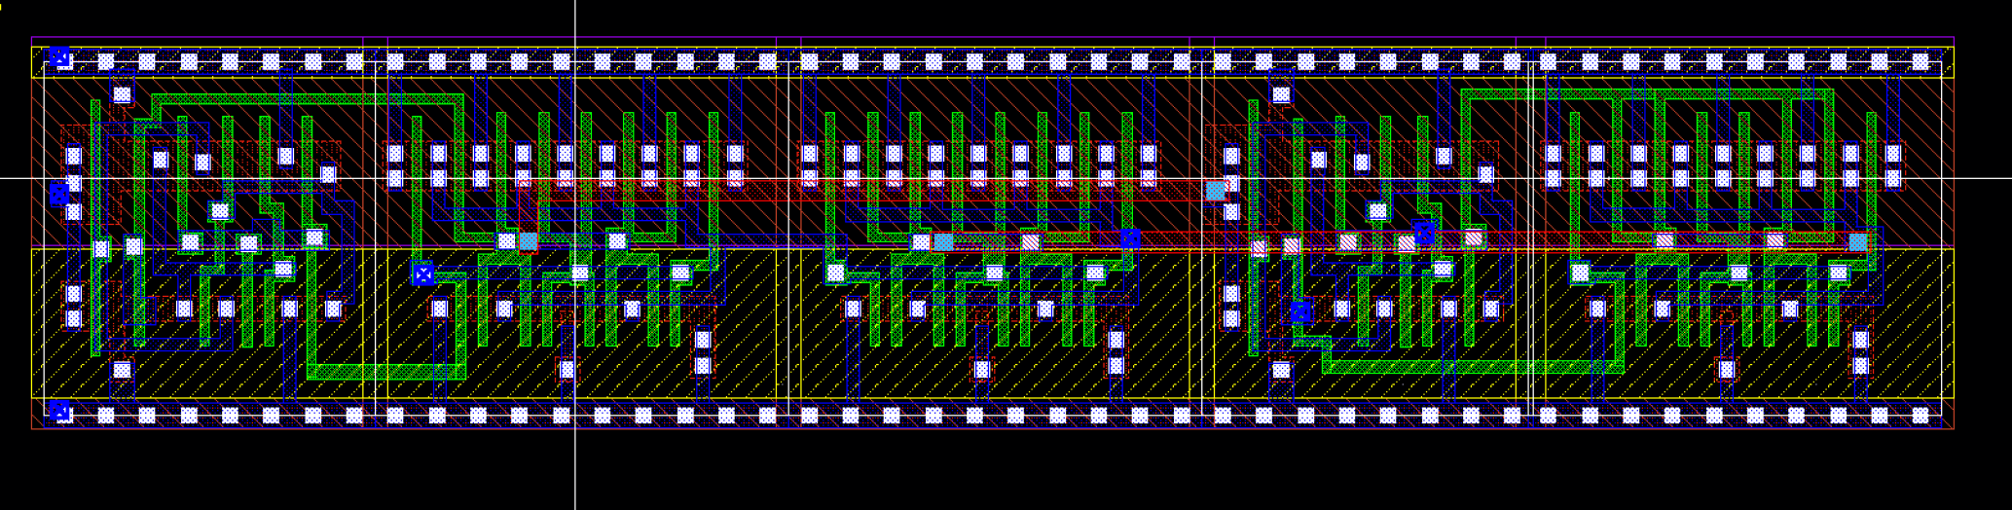

### DRC

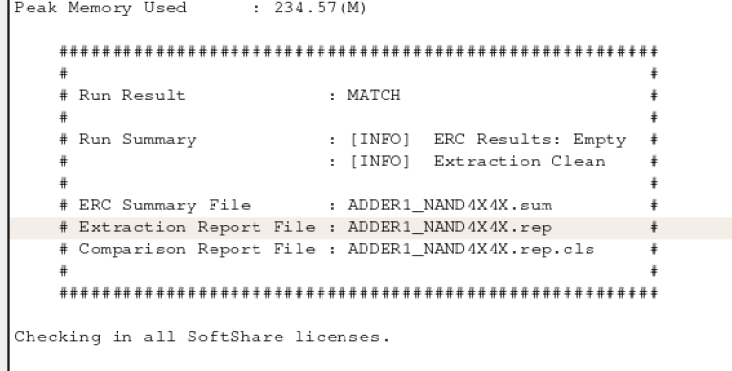

### LVS

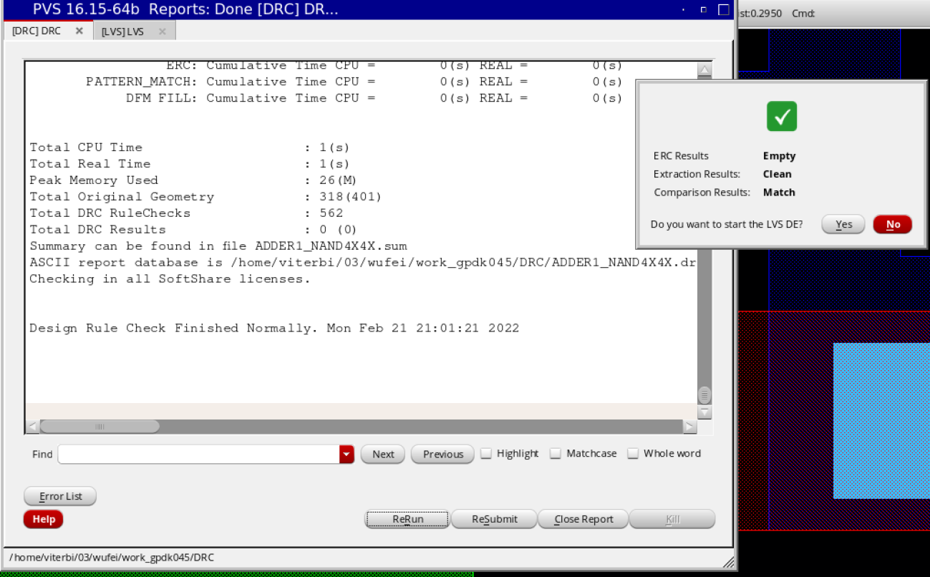

## MUL

### Changes

Some slight changes on the mul.

Choosing to use the full adder1 to consist the multiplexer, which will make the layout much more structured.

By changing the schematic, retest the logic correct

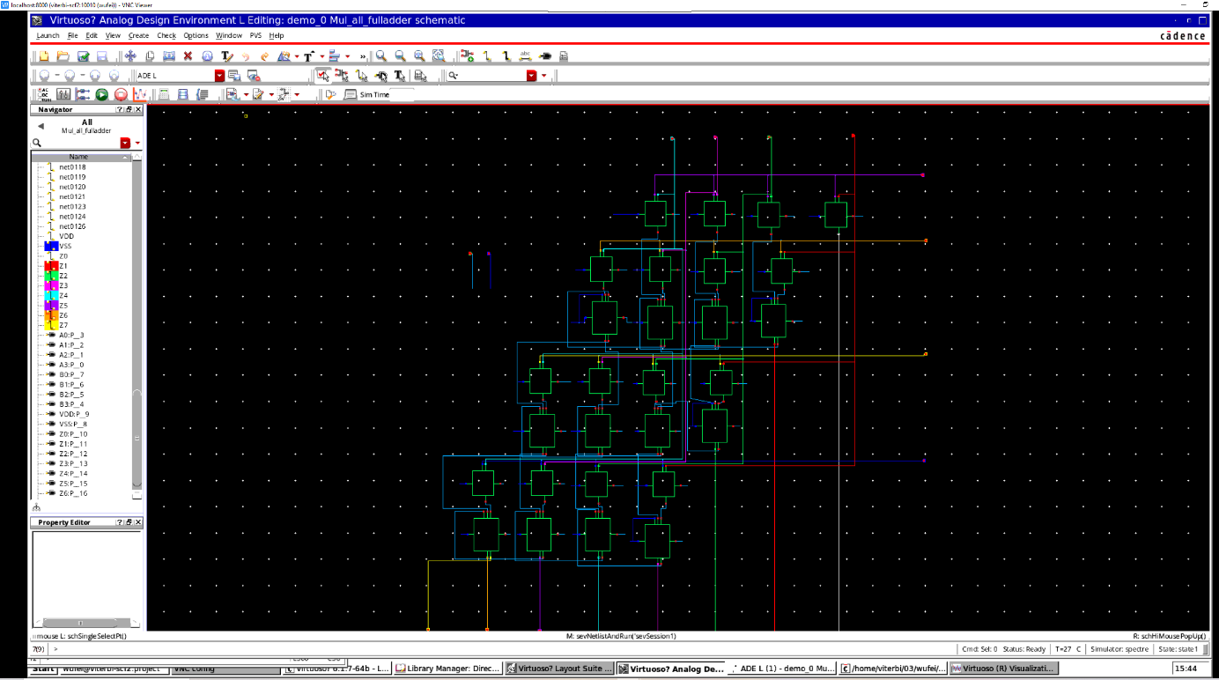

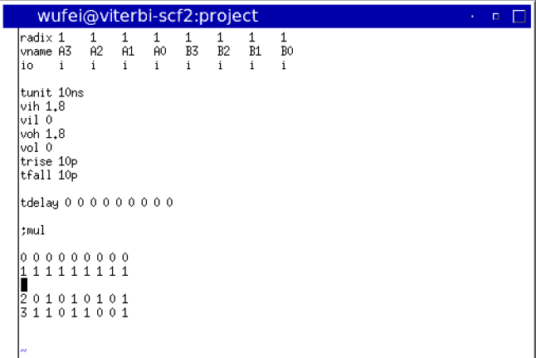

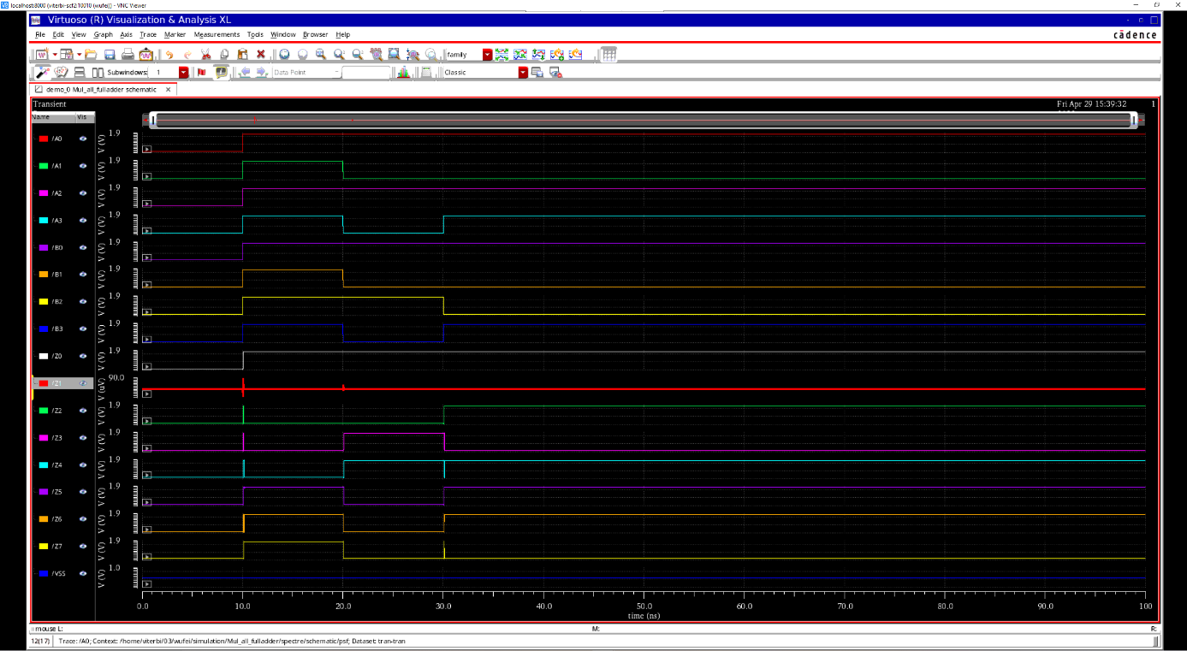

### Layout

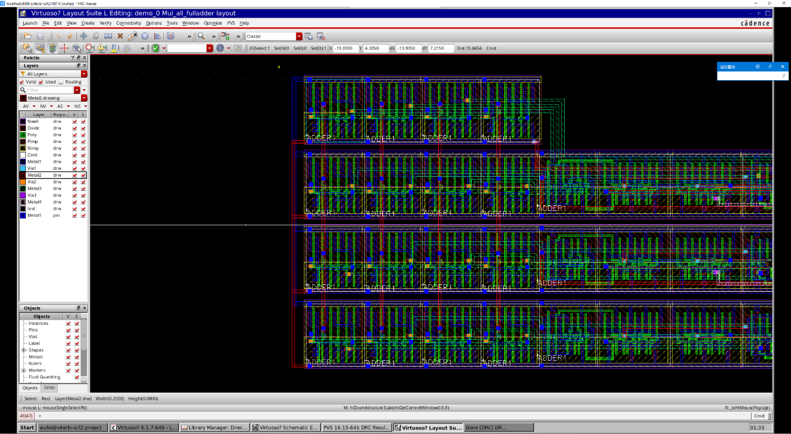

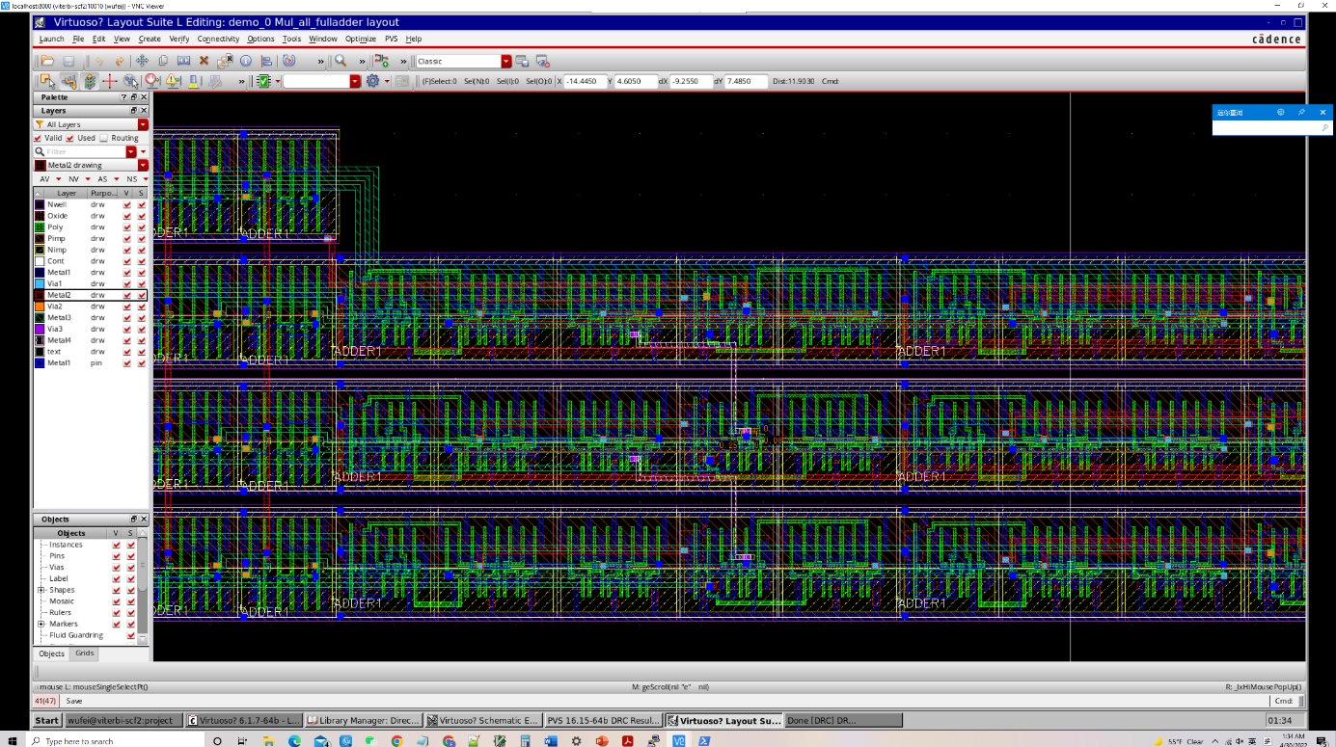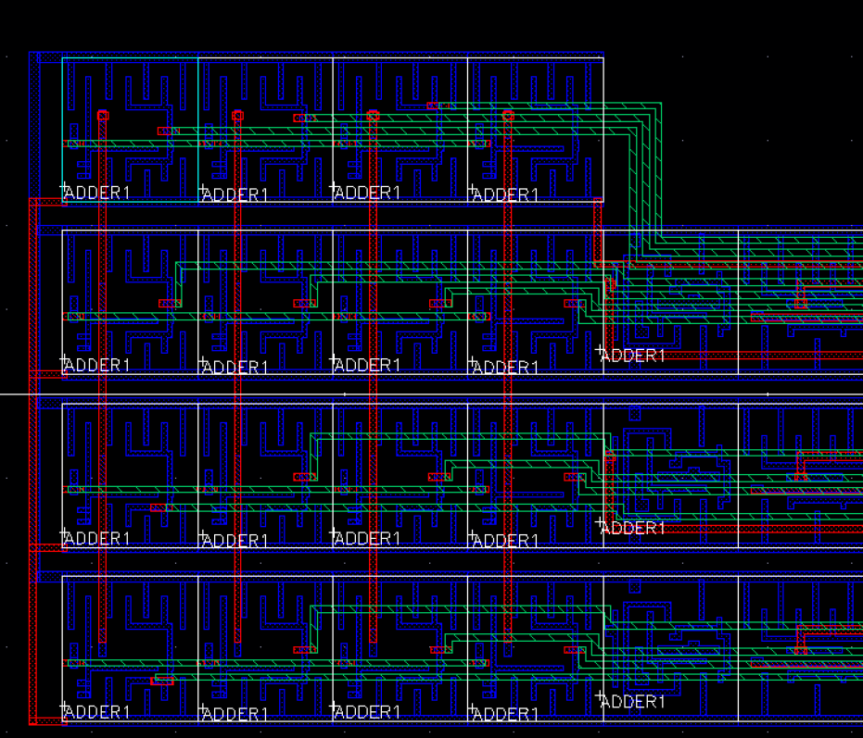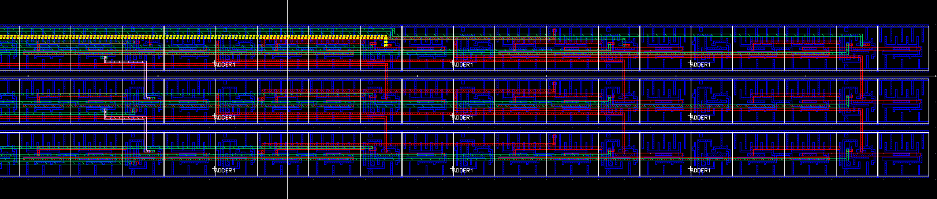

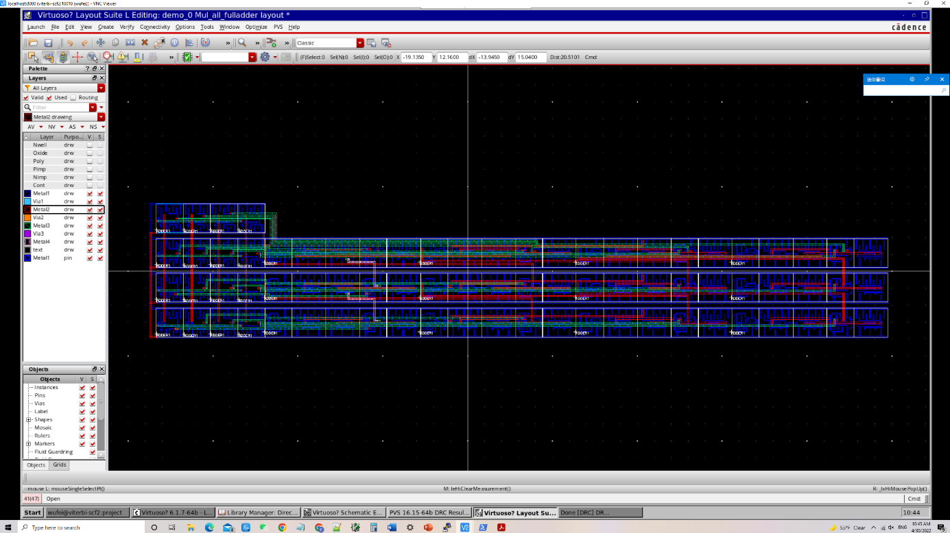

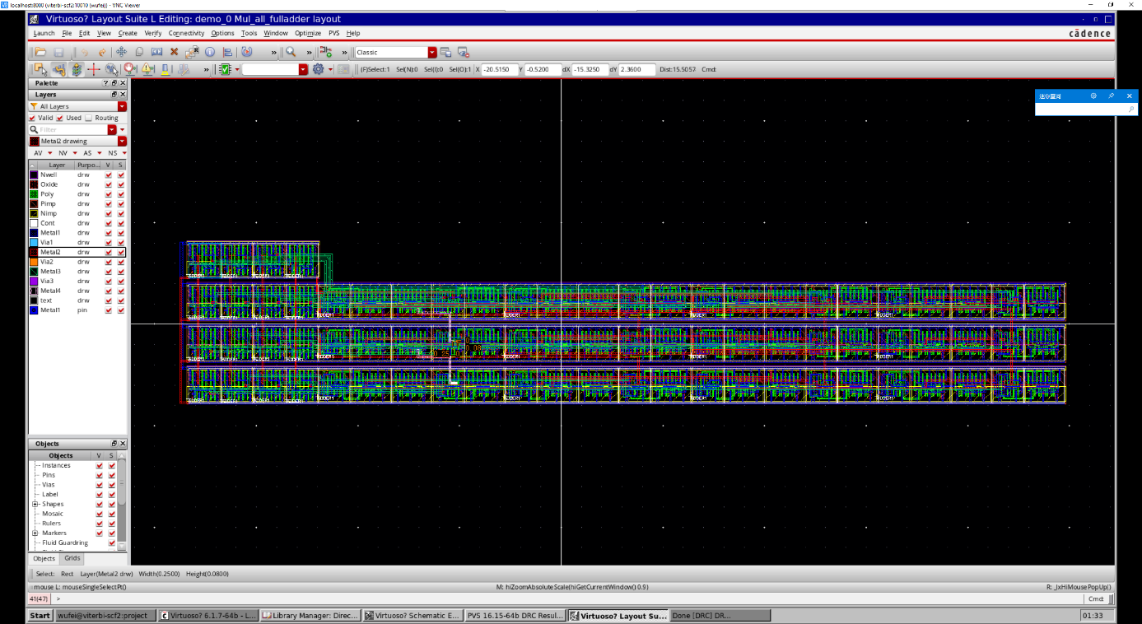

### DRC

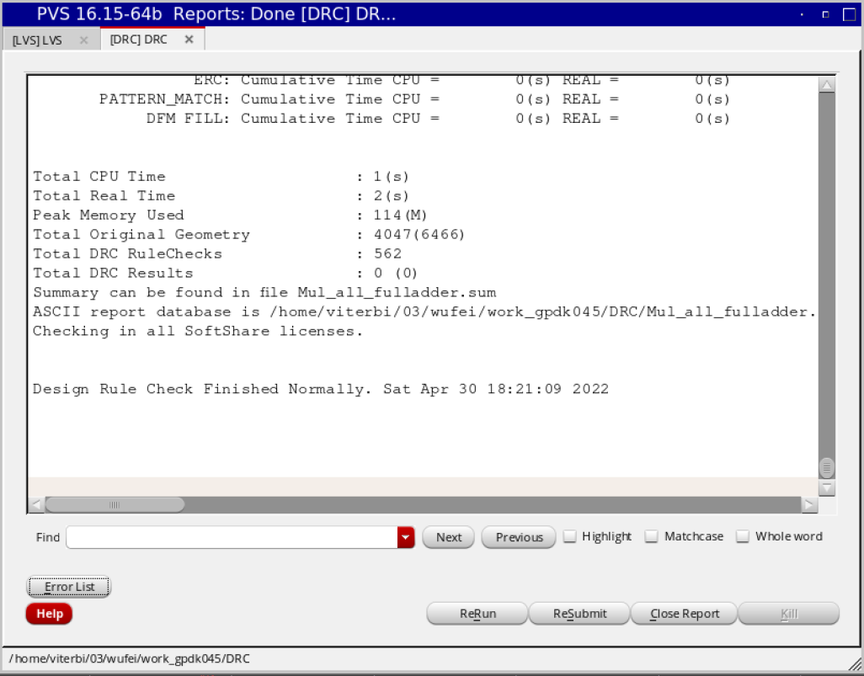

### LVS

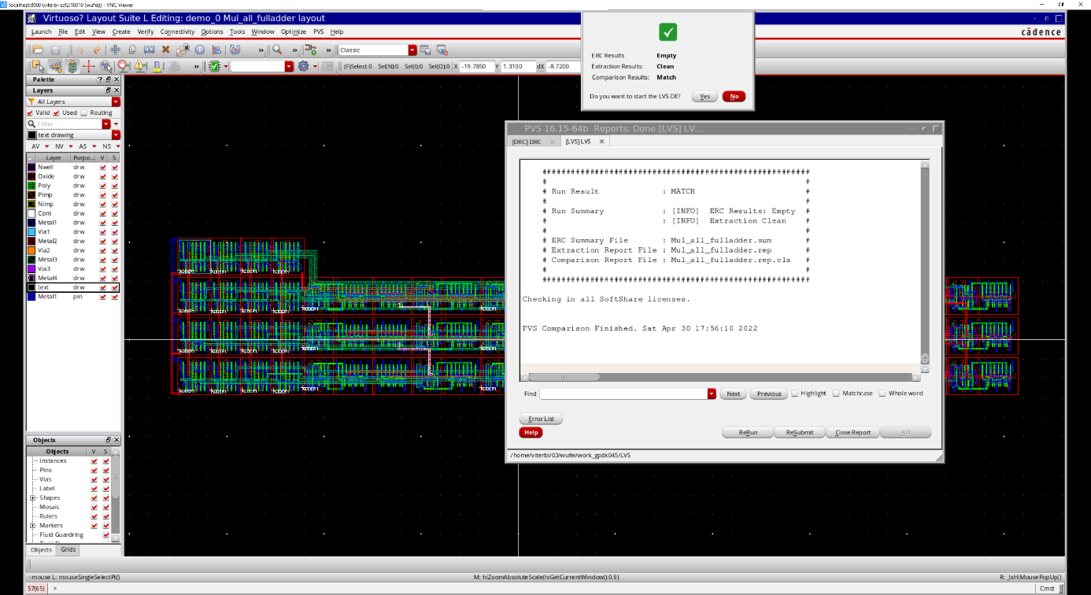

# Divider

## Halfsub

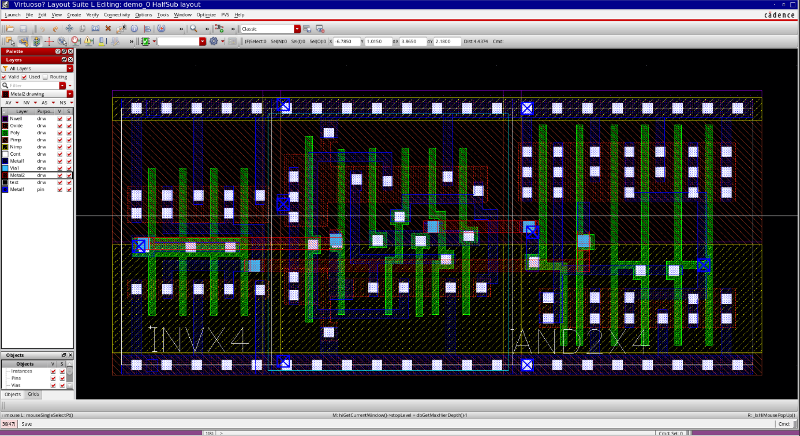

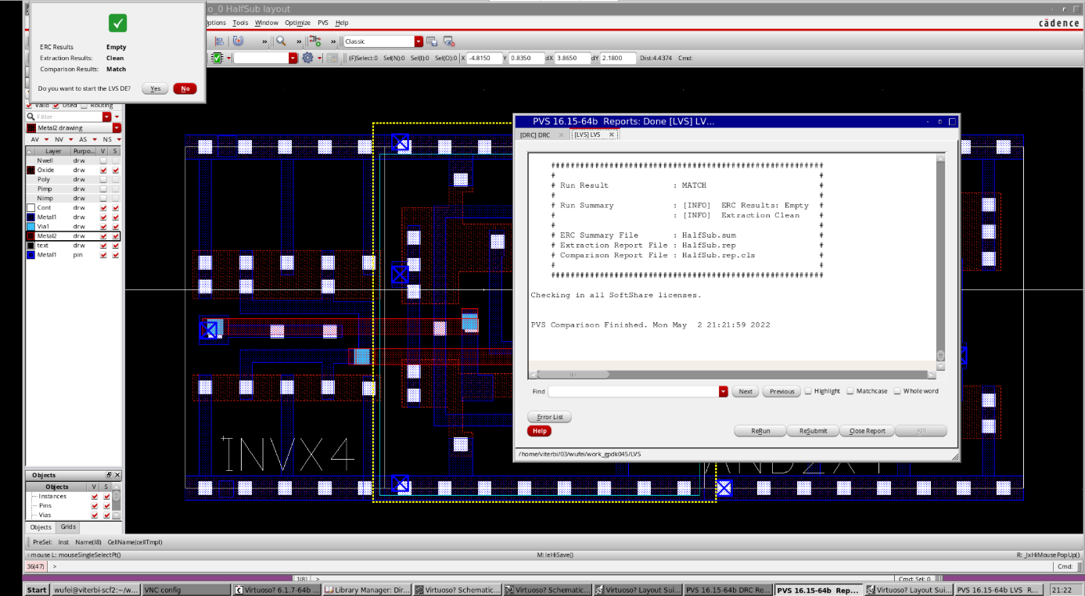

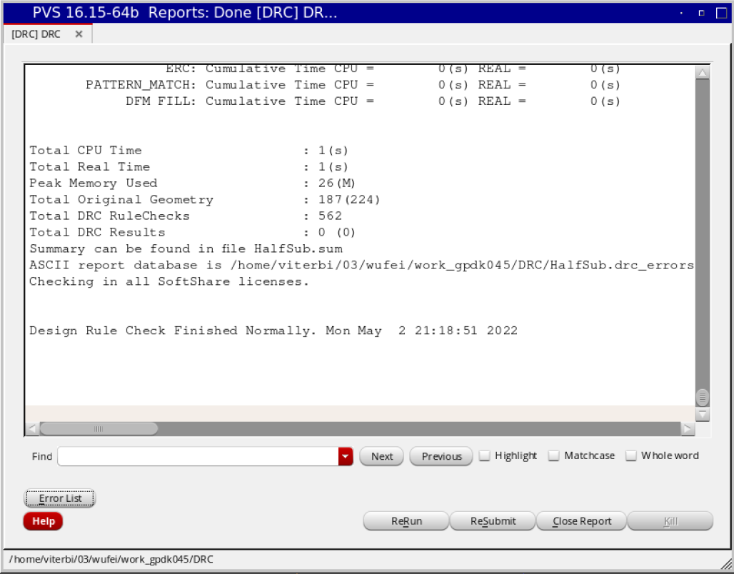

## Fullsub

### Loyout

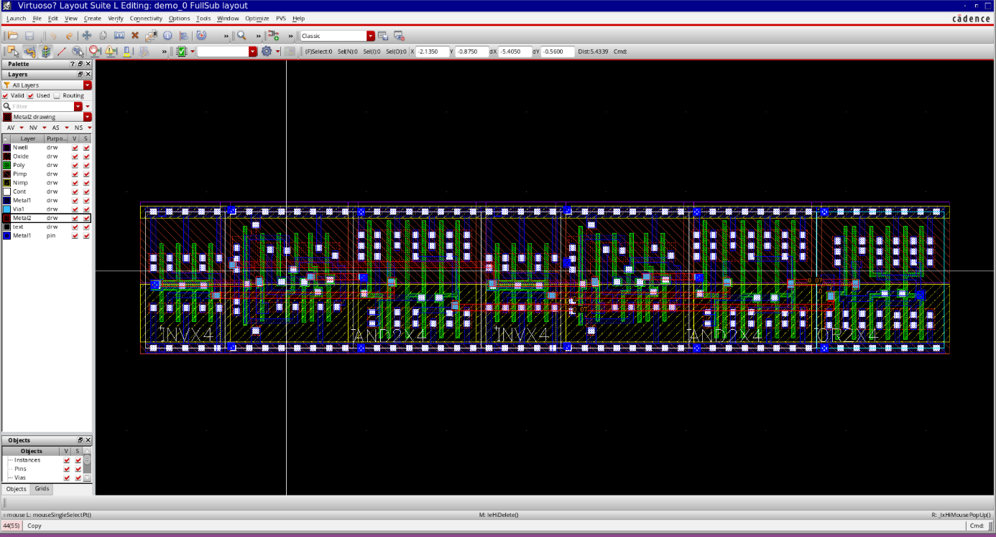

### LVS

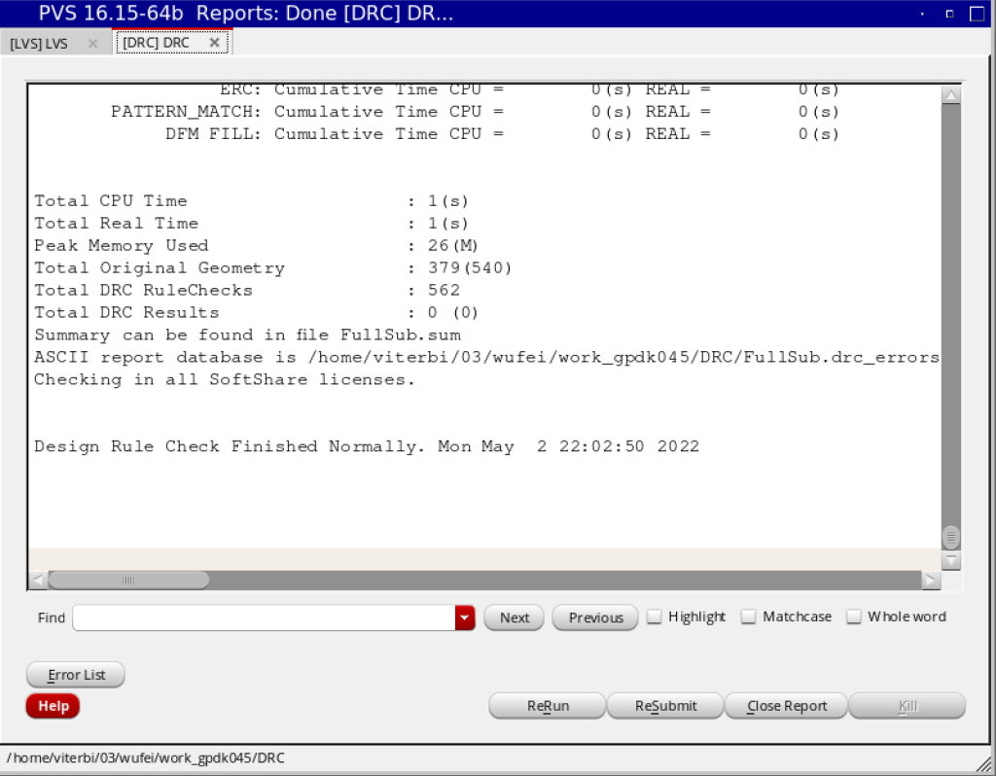

### DRC

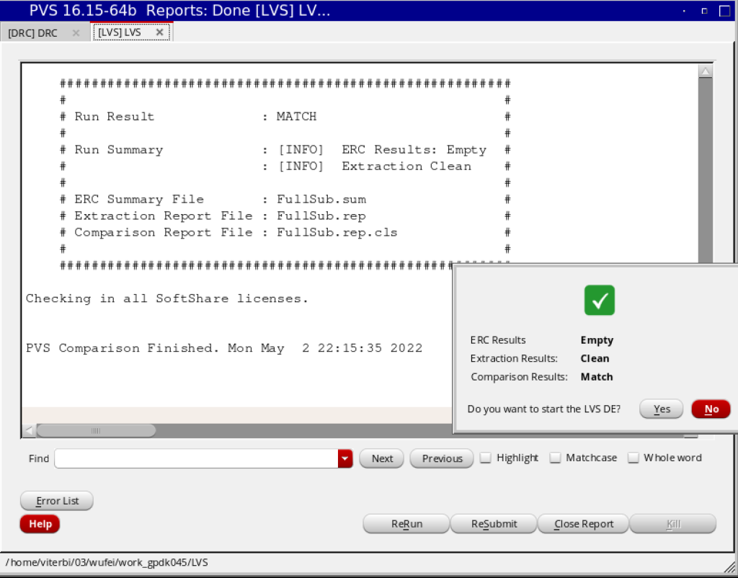

## FullSubmux

### Layout

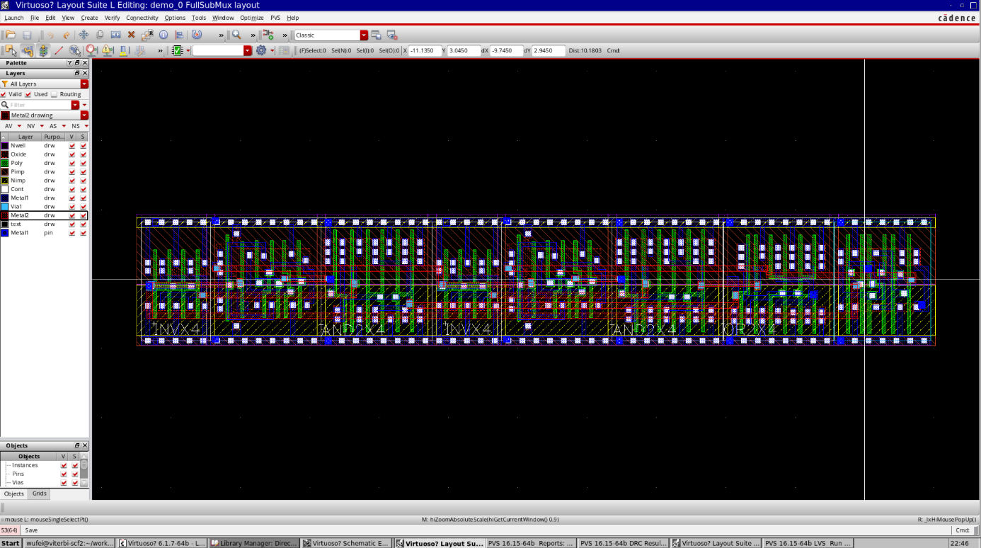

### DRC

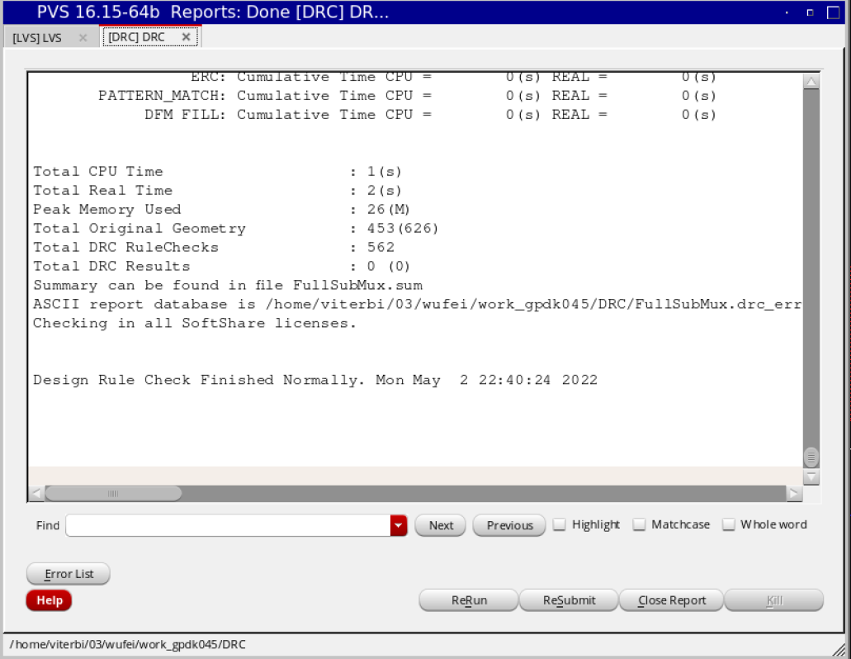

### LVS

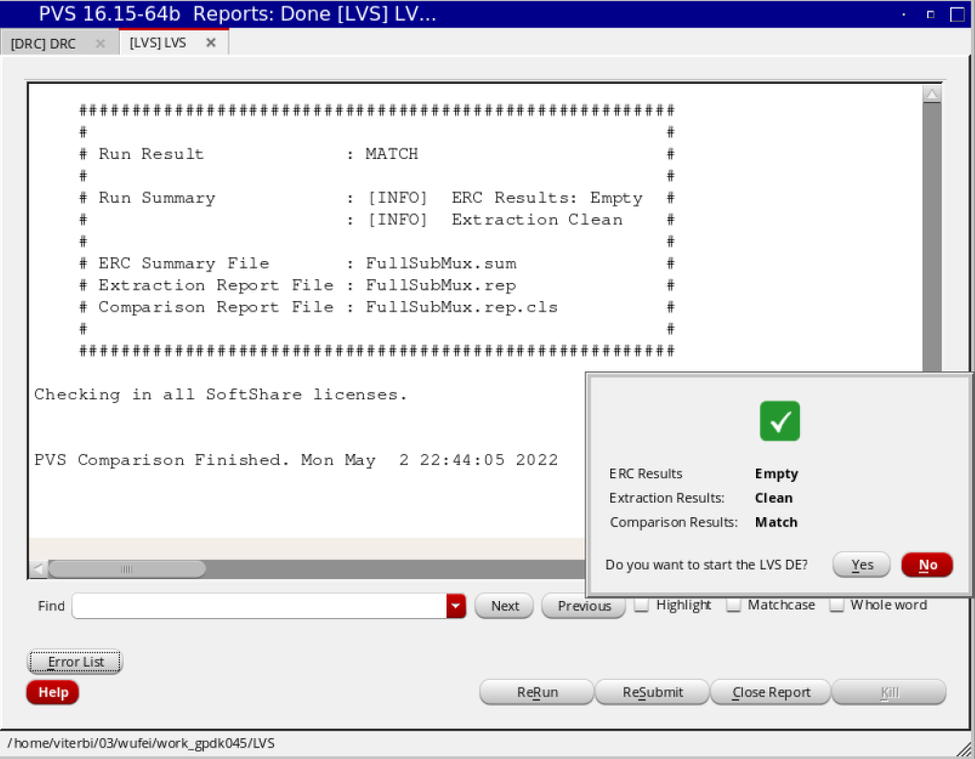

## HalfsubMux

### Layout

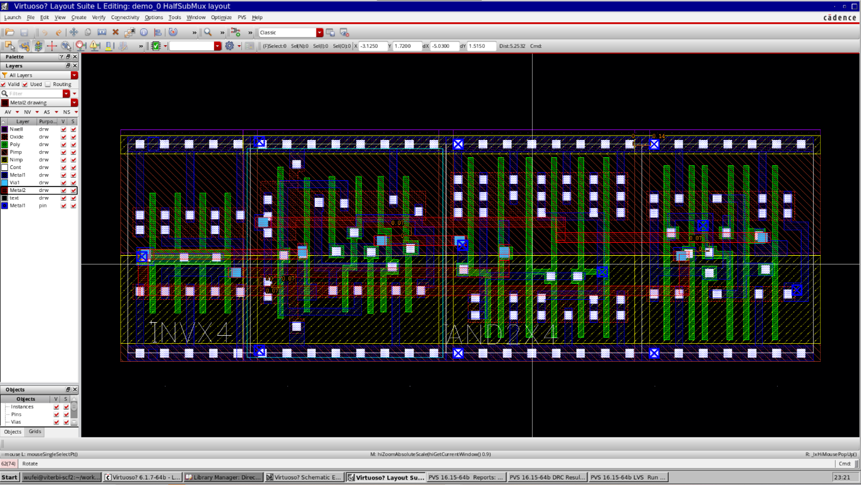

### LVS

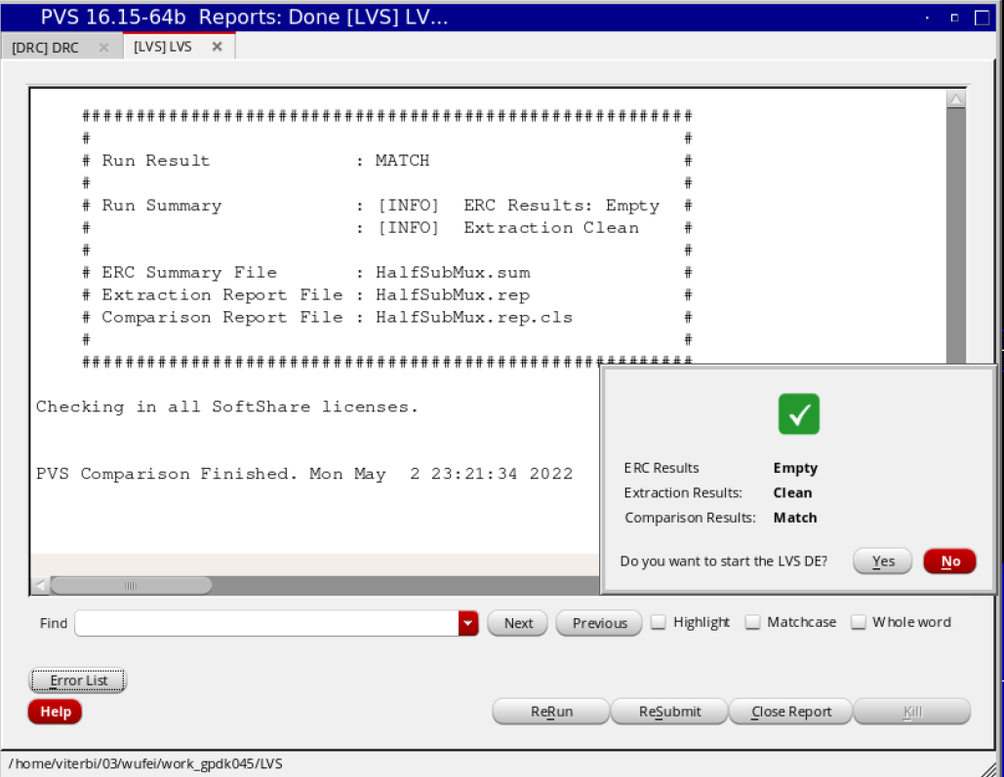

### DRC

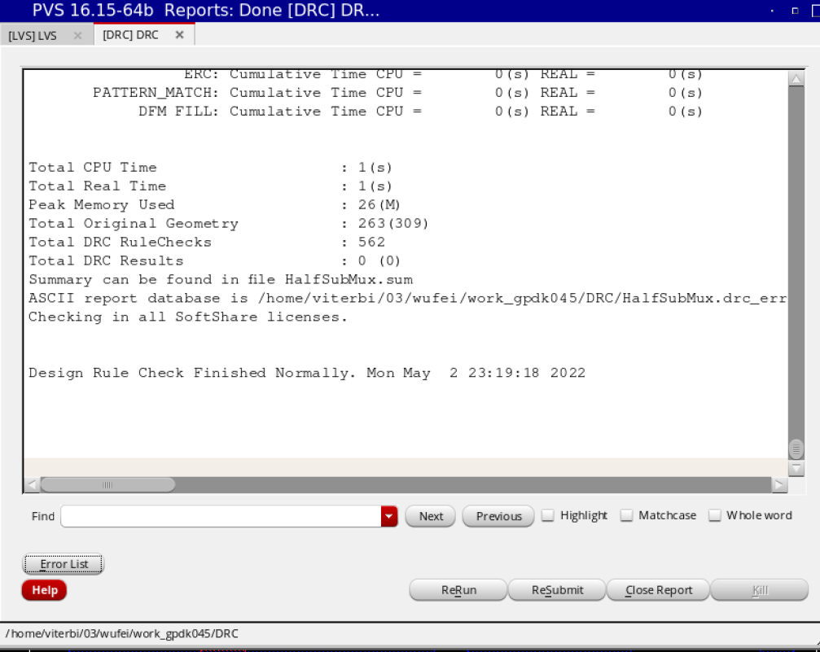

## Divider

### Layout

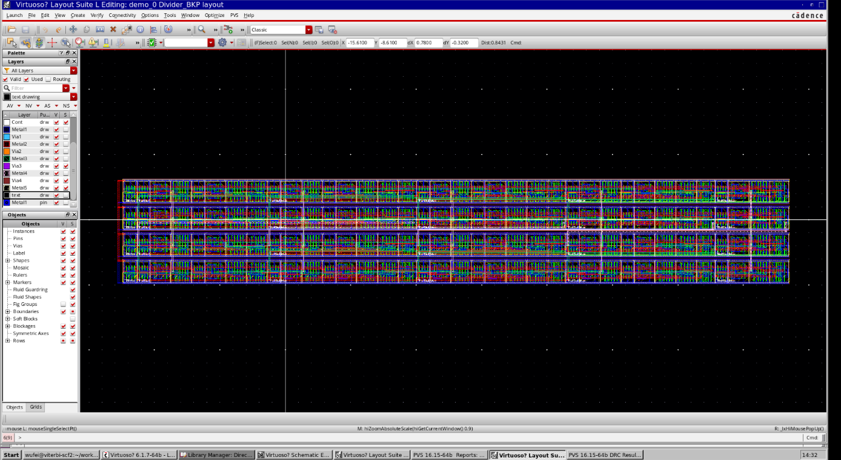

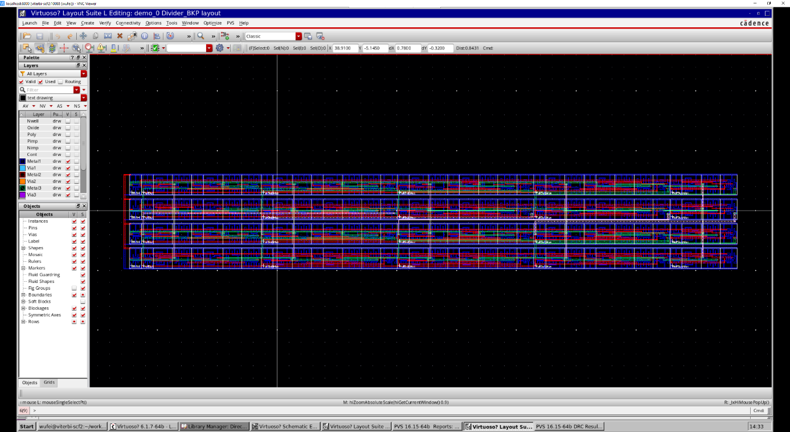

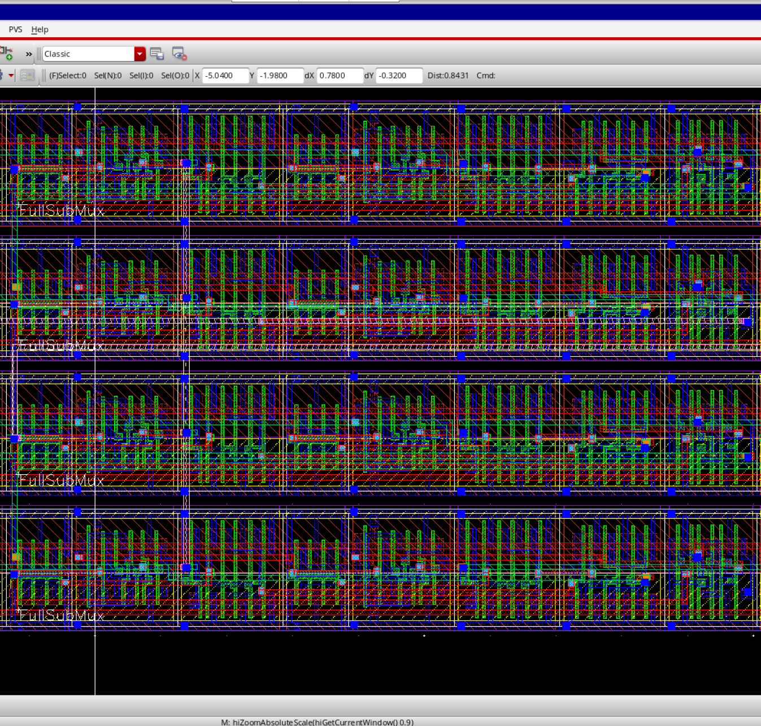

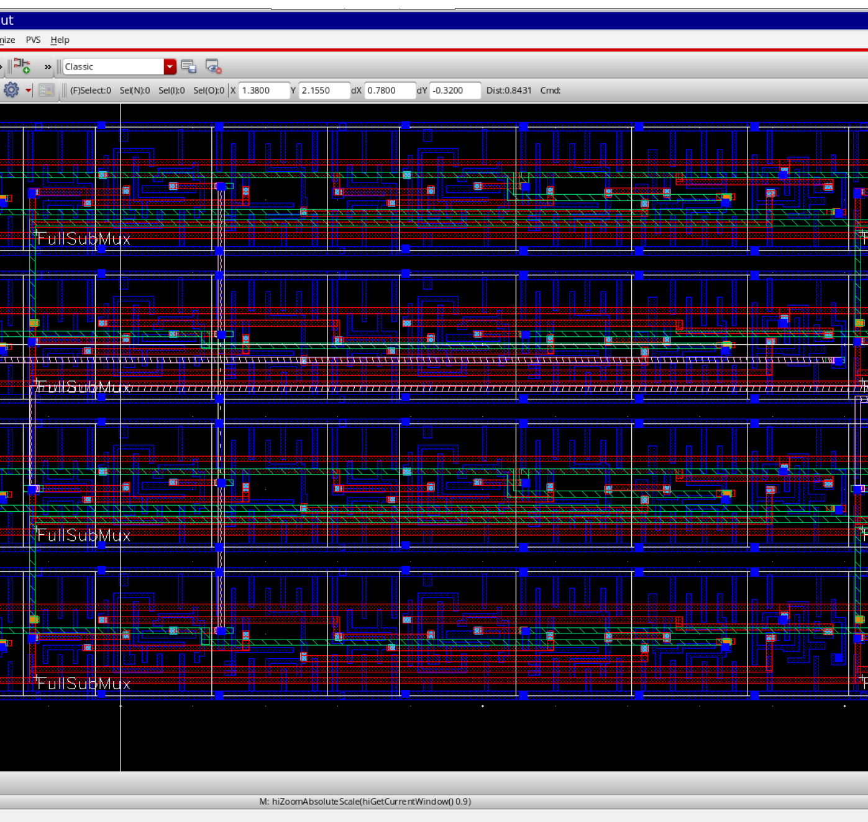

### LVS

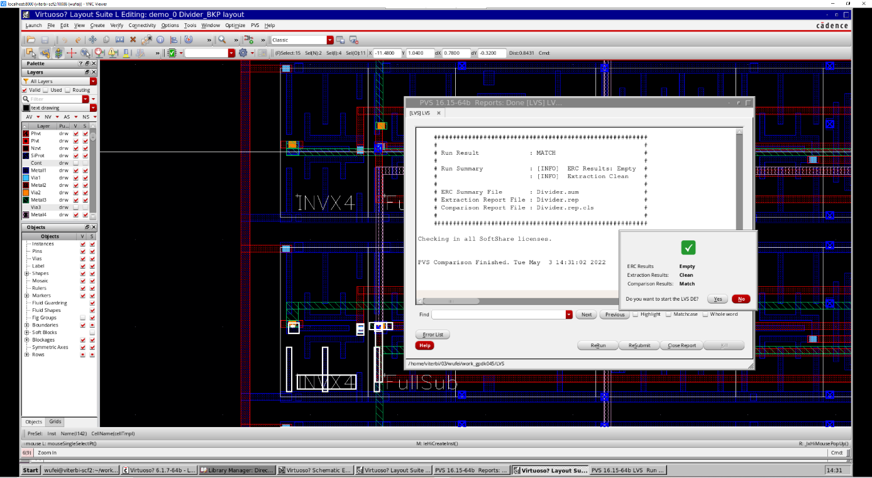

### DRC

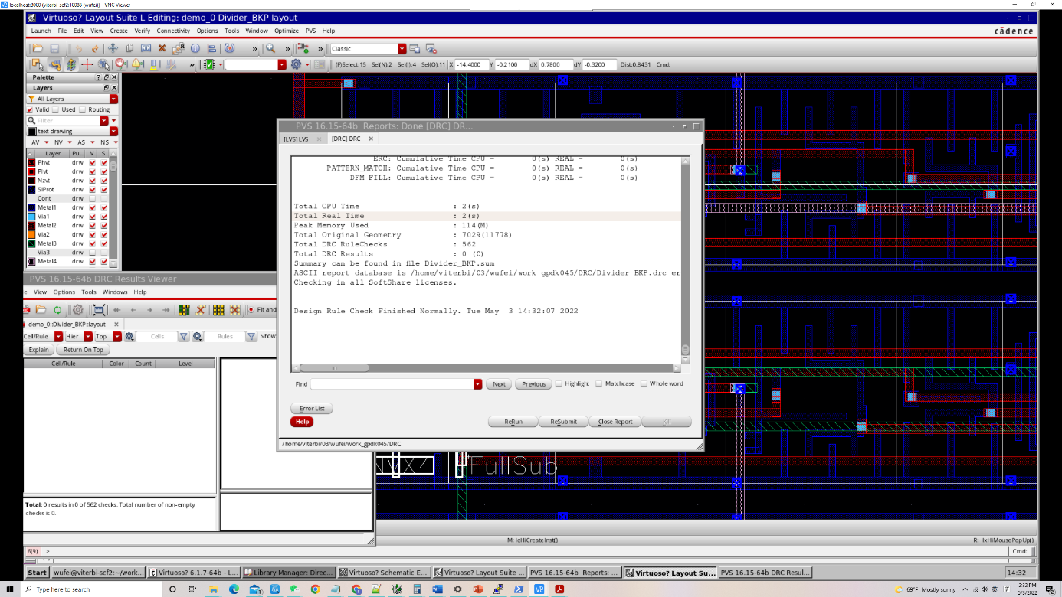

# FSM

## DFF

### Layout

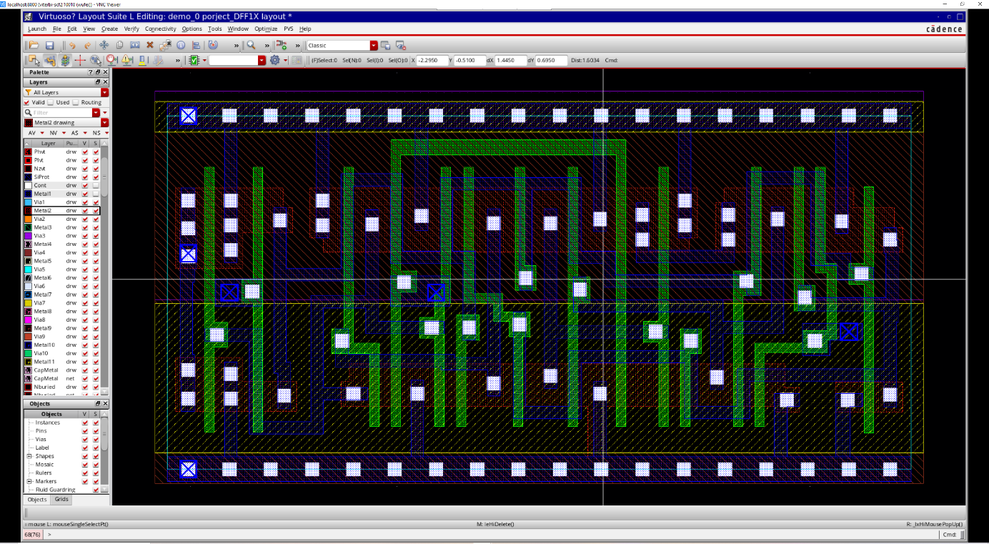

### DRC

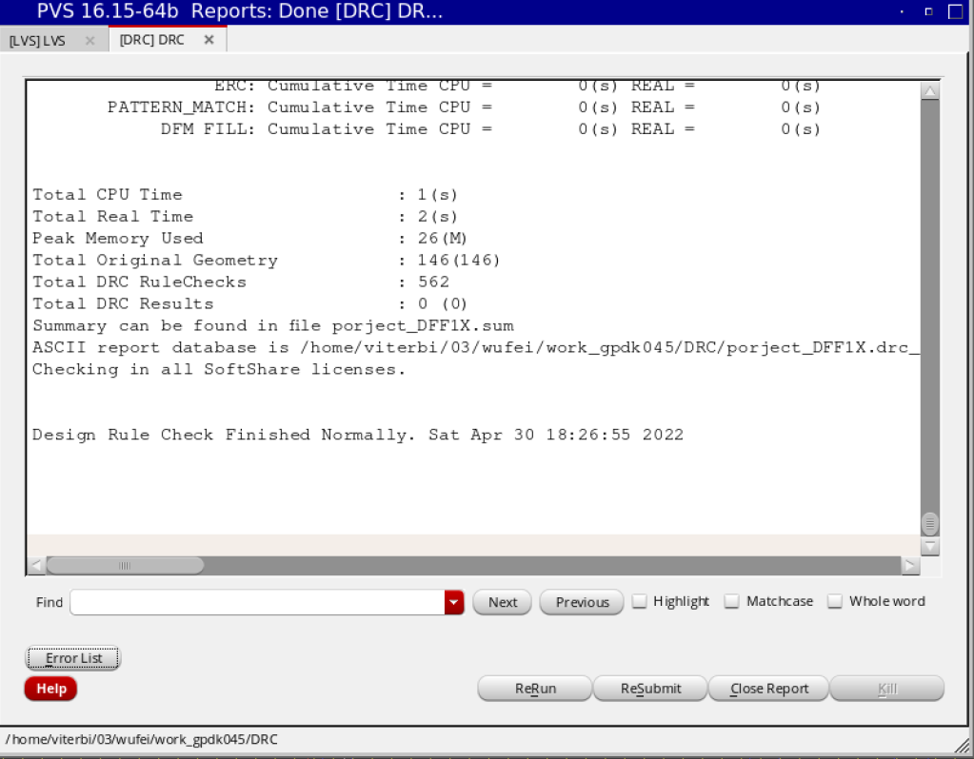

### LVS

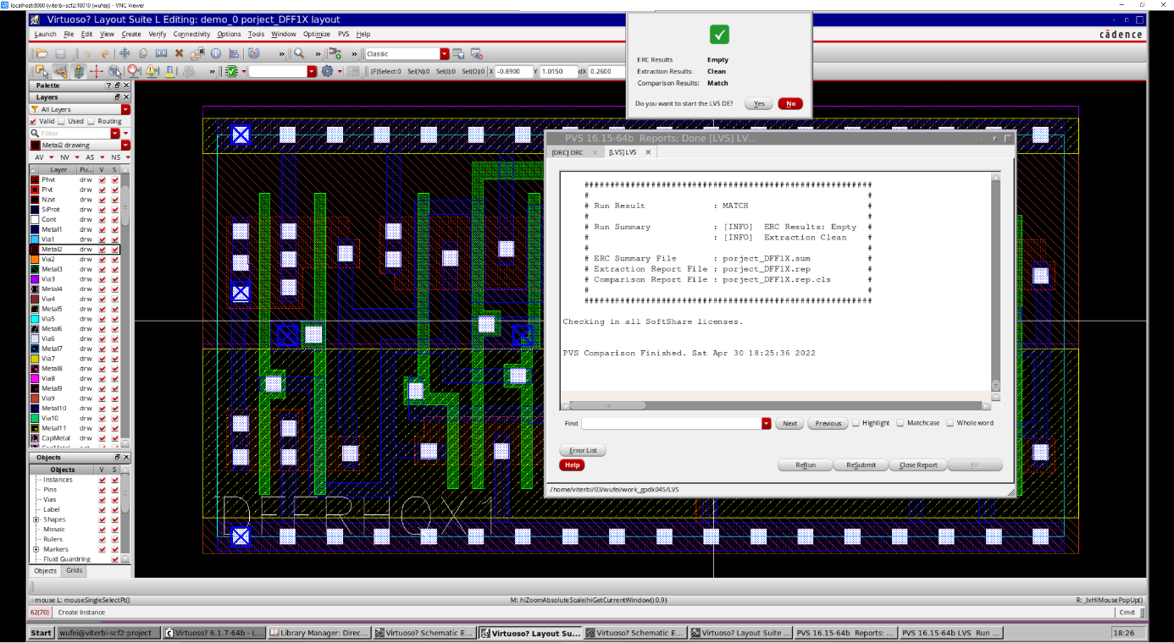

## Arbiter

### Layout

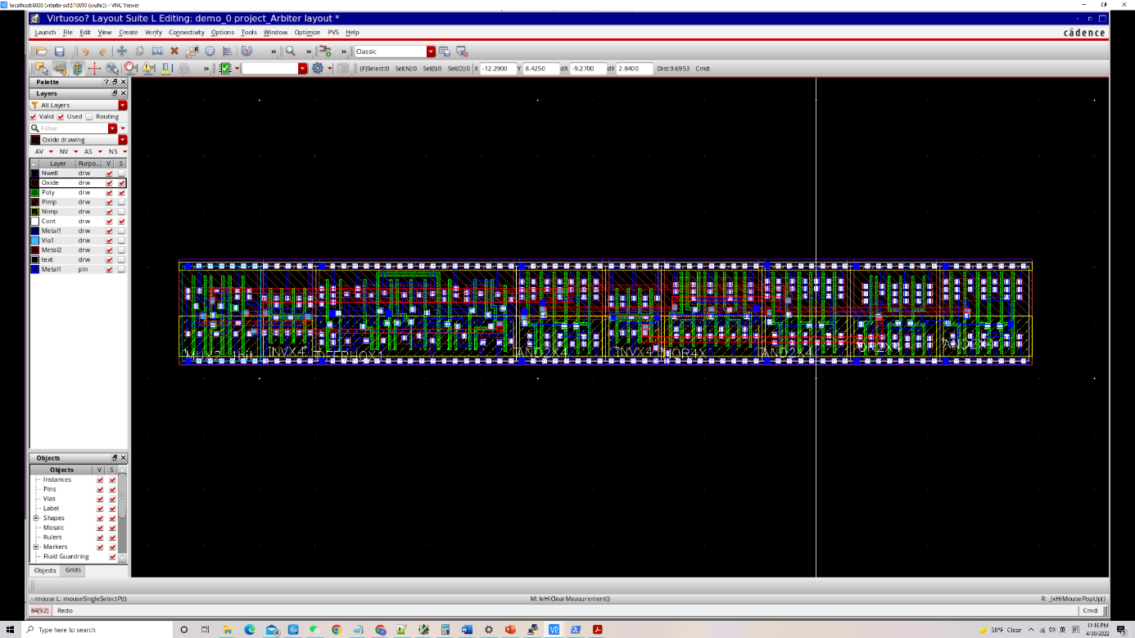

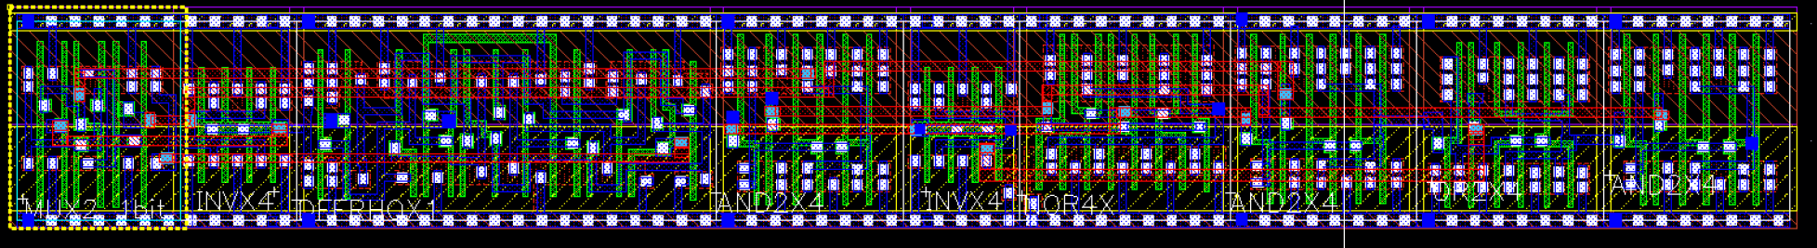

### LVS

### DRC

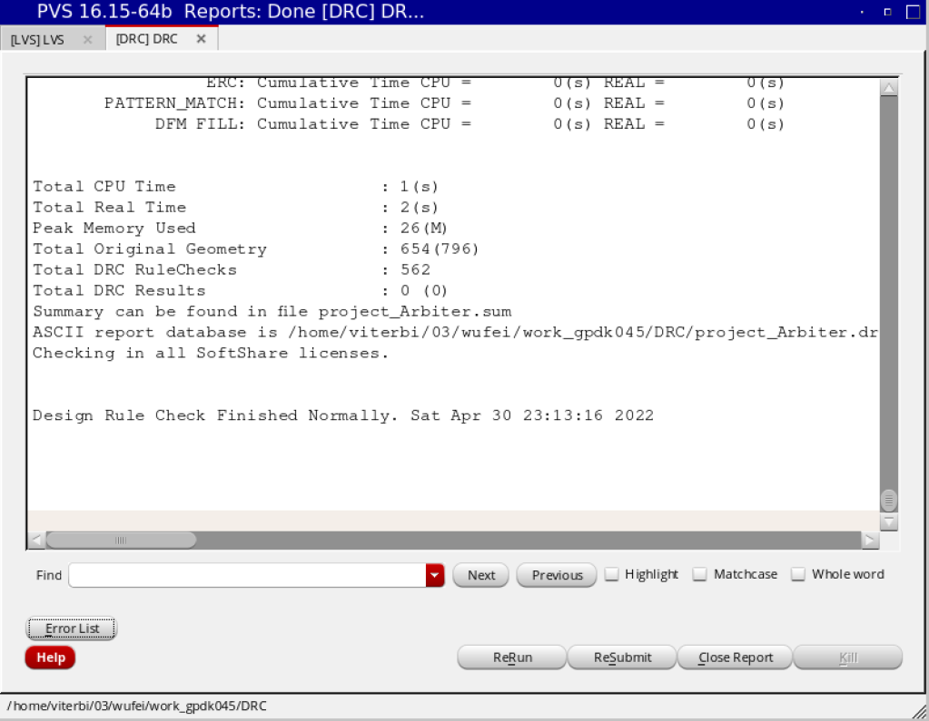

## FSM

### Layout

3layer:

1. Divider
2. Arbiter and Mux set
3. Multiplexer

I have showed all the detail above, the following image just the overview of the FSM and the interconnection of the components.

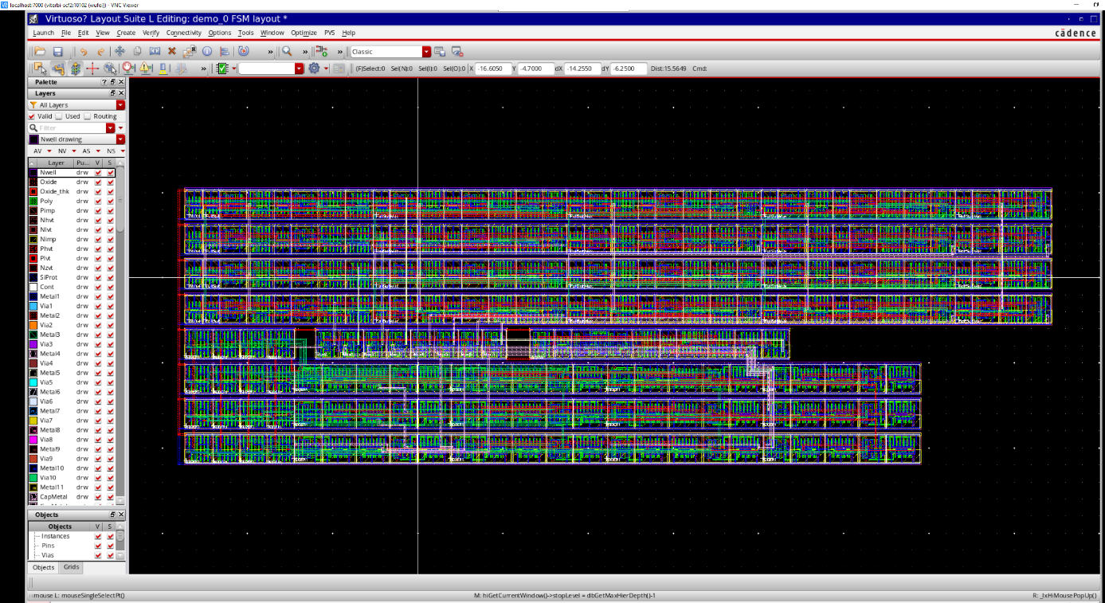

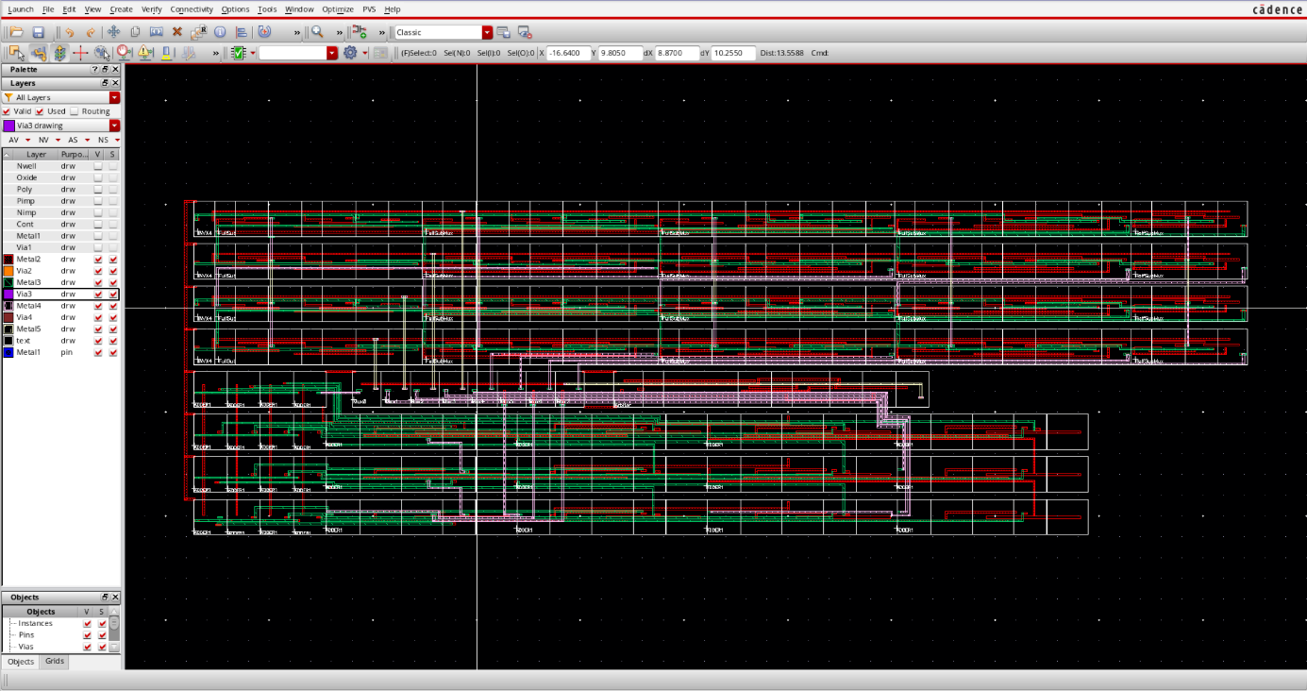

### DRC

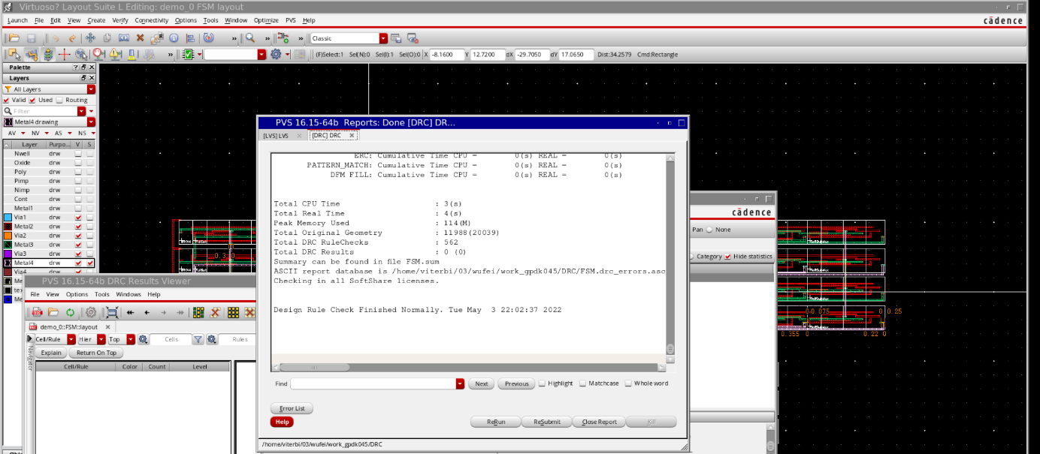

### LVS

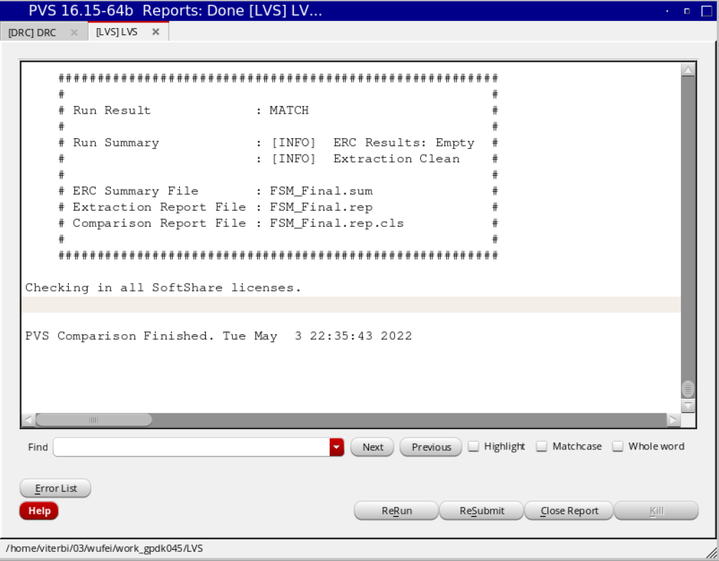

# Test Conclusion

**Minimum time period:** 0.234ns

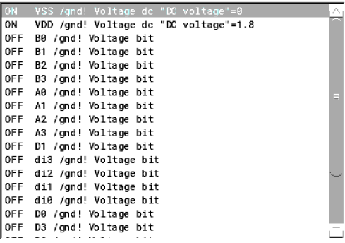

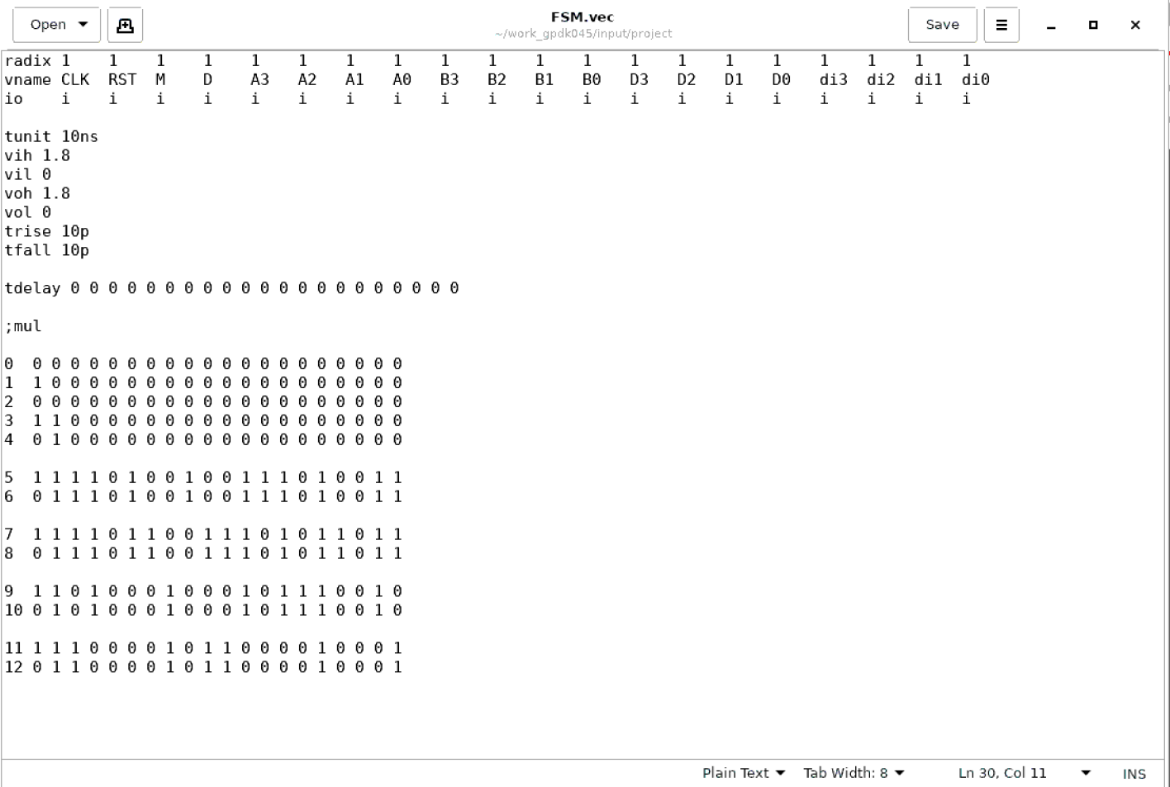

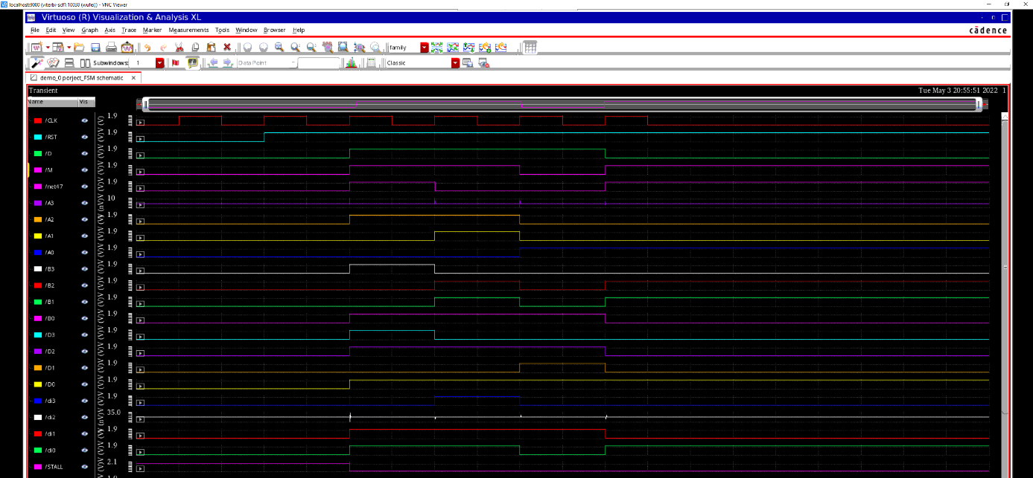

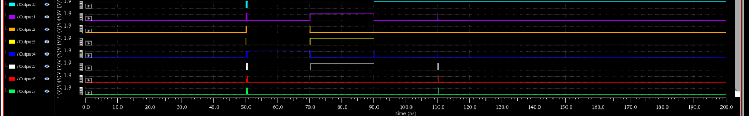

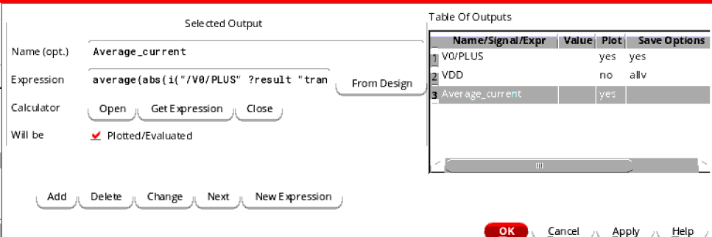

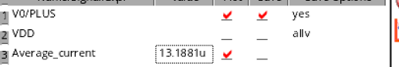

Power = 13.1881uA * 1.8V = 23.73858 uW